|  |  |  |
| --- | --- | --- |
|  |  | Project 1  Blinking led project |

13/07/2022

# AIM

To make a circuit with a LED such that it blinks for a second and goes off and blinks again in a continuous loop.

# Materials required

## Physical components

|  |  |
| --- | --- |
| Generic LED | 1 |
| Jumper Wires | 1 pack |
| Generic Breadboard | 1 |
| Resistor 220 kΩ | 1 |
| Arduino UNO | 1 |

## System Components

|  |
| --- |
| Arduino App |

## Others (Optional)

|  |
| --- |
| Tinkercad ( For diagram ) |
| Multimeter (to measure resistor ) |

# Diagram, schematic Description automatically generatedCircuit connection

Schematic Diagram

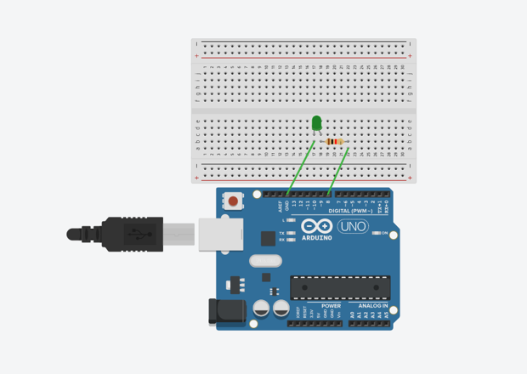

Connections diagram

# Code

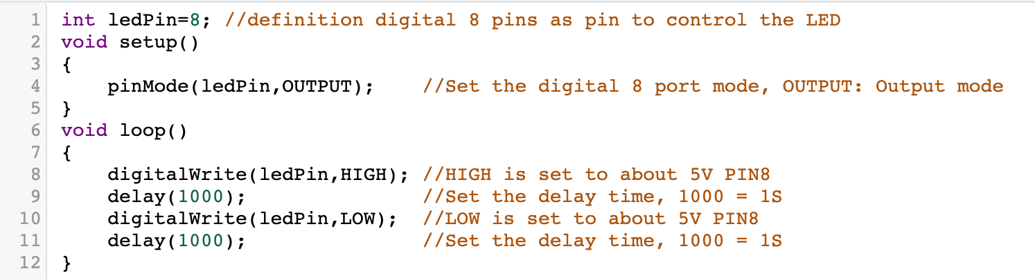

## PERSONAL NOTES

1. Void setup & Void loop 🡪 function setup & draw
2. pinMode 🡪 used to define what pin is used and for what purpose
3. digitalWrite 🡪 works like switch HIGH means electricity flowing LOW means stopped

# observations

* LED blinks for a second and becomes dull again

# Precautions

1. Make sure resistor is of correct measure
2. Make sure code is debugged

- semi colons on all lines

- parenthesis

1. Make sure right port is connected ( Tools < Port )

# Results

*double click to turn on video or use the link*

<https://youtu.be/AEH5HM9n7T8>